How to Close a Request
- Click the Select tool button 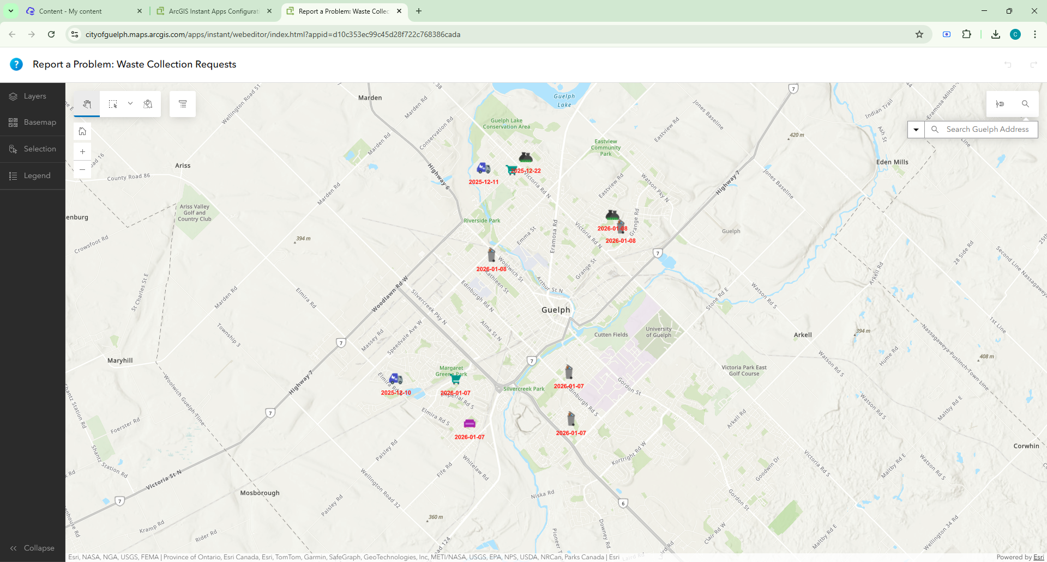
- Click on or draw a rectangle around the desired Open Issue.
- Click the Attributes button to open the Attribute Window Editor. Fields greyed out are not editable where fields that are white need to be updated. The last 2 fields (Resolved On and Completed By) are automatically calculated upon closure.
- Click Save to Save the edits (or Cancel should you not want to save the edits).

How to Re-Open a Recently Closed Request
- Click on the Layers button on the left side of the screen to expand the layer list. There are two layers Open and Closed. Ensure the Closed Layer is visible.
- Click the Select tool button
- Click on or draw a rectangle around the desired Closed Issue.
- Click the Attributes button to open the Attribute Window Editor. Change the Status from Completed/Canceled to Open and add any additional information in the Internal Notes area. The last 2 fields (Resolved On and Completed By) are automatically calculated upon closure.
- Click Save to Save the edits (or Cancel should you not want to save the edits).

