THE CORPORATION OF THE CITY OF GUELPH

By-law Number (2017) – 20213

A by-law to amend By-law Number (1995)-14864, as amended, known as The Zoning By-law for the City of Guelph as it affects property municipally known as 1229 Victoria Road South and legally described as Part of Lot 10, Concession 8, Geographic Township of Puslinch, City of Guelph (File: ZC1507)(OMB Case # PL 160859) and to repeal By-law 2016-20079.

WHEREAS the Ontario Municipal Board issued an order (Case No. PL160859 dated September 7, 2017) and deems it desirable to amend City of Guelph By-law (1995)-14864, as amended, pursuant to Section 34 of the Planning Act, R.S.O. 1990;

NOW THEREFORE THE ONTARIO MUNICIPAL BOARD HEREBY ENACTS AS FOLLOWS:

- By-law Number (1995)-14864, as amended is hereby further amended by transferring property legally described as Part of Lot 10, Concession 8, Geographic Township of Puslinch, City of Guelph, municipally known as 1229 Victoria Road South, from the existing ‘A’ (Agricultural) Zone under the former Township of Puslinch Zoning By-law No. 19/85 to an ‘R.4A-51’ (Specialized General Apartment) Zone and to the ‘NC’ (Neighbourhood Commercial) Zone to permit the development of a 101-unit apartment building and a neighbourhood commercial mall.

- Section 5.4.3.1 of By-law (1995)-14864, as amended, is hereby further amended by adding the following new subsection 5.4.3.1.51:

5.4.3.1.51 R.4A-51
1229 Victoria Road South
As shown on Defined Area Map Number 75 of Schedule “A” of this By-law.

5.4.3.1.51.1 Permitted Uses
All Uses outlined in Section 5.4.1.1 of this By-law.

5.4.3.1.51.2 Regulations
In accordance with the provisions of Section 4 (General Provisions), Section 5.4.2 and Table 5.4.2 of Zoning By-law (1995)-14864, as amended, with the following exceptions and additions:

            - Minimum Rear Yard
Despite Table 5.4.2, Row 9 of this By-law, the minimum Rear Yard shall be 7.5 metres, whereas the Zoning By-law requires a minimum Rear Yard of 21.52 metres.

            - Parking Area Setback
Despite Section 4.13.2.2 of this By-law, every Parking Space shall be located in the Side or Rear Yard provided that no Parking Space is located within 1 metre of any Lot Line, whereas the Zoning By-law requires no Parking Space to be located within 3 metres of any Lot Line.

            - Frontage on a Street
Despite Section 4.1 of this By-law, access from a Building to a public Street may be provided by way of a private Street.

- Schedule “A” of By-law Number (1995)-14864, as amended, is hereby further amended by deleting Defined Area Map 75 and substituting therefore new Defined Area Map 75 attached hereto as Schedule “A”.

- This by-law shall come into effect on the day of approval per an Order from the Ontario Municipal Board (OMB Case No. PL160859) dated September 7, 2017 as attached hereto.

IN FORCE AND EFFECT BY ONTARIO MUNICIPAL BOARD ORDER ISSUED SEPTEMBER 7, 2017, CASE NO. PL160859.

SCHEDULE “A”
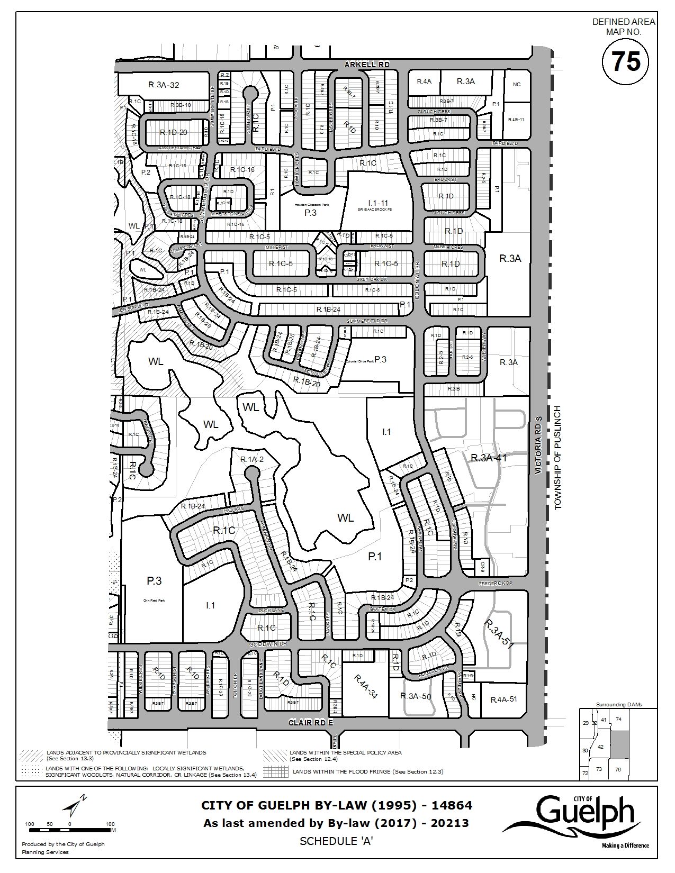

MAP AMENDED BY OMB ORDER PL160859 DATED OCTOBER 5, 2017

