THE CORPORATION OF THE CITY OF GUELPH

By-law Number (2015)-19968

A by-law to amend Zoning By-law (1995)-14864, as amended, known as the Zoning By-law for the City of Guelph as it affects property known municipally as 78 Starwood Drive and legally described as Part of Lots 4 and 5, Concession 3, Division C, Township of Guelph, Being Part 3, 61R-10049, City of Guelph (ZC1315) OMB Order for file PL150062 and to repeal By-law (2014)-19836.

WHEREAS the Ontario Municipal Board issued an Order for file PL150062 on August 25, 2015, to Amend the Zoning Amendment By-law (2014)-19836 regarding the property known as 78 Starwood Drive, pursuant Section 34 (1) of the Planning Act, R.S.O. 1990, c.P.13;

NOW THEREFORE THAT THE FOLLOWING BE ENACTED:

- By-law Number (1995)-14864, as amended, is hereby further amended by transferring property legally described as Part of Lots 4 and 5, Concession 3, Division C, Township of Guelph, Being Part 3, 61R-10049, City of Guelph and municipally known as 78 Starwood Drive from the B.1 (Industrial) Zone and UR (Urban Reserve) Zone to the R.4B-16 (Specialized High Density Residential) Zone, R.4B-16 (H27) (Specialized High Density Residential) Holding Zone, R.1D (H28) (Single Detached Residential) Holding Zone and P.1 (Conservation Land) Zone to permit the development of approximately 405 residential apartment units and ground level commercial uses along Starwood Drive.
- Section 5.4.3.2 of By-law Number (1995)-14864, as amended, is hereby further amended by adding a new subsection 5.4.3.2.16:

5.4.3.2.16 R.4B-16
78 Starwood Drive
As shown on Defined Area Map Number 62 of Schedule “A” of this By-law

5.4.3.2.16.1 Permitted Uses
In accordance with Section 5.4.1.2 of Zoning By-law (1995)-14868, as amended, with the following additions:

- Retirement Residential Facility to a maximum of 150 units
- Live/Work Units
- Office
- Medical office
- Retail establishment
- Artist studio
- Gallery
- Personal service establishment
- Convenience store
- Restaurant
- Restaurant (take-out)
- Dry cleaning outlet

The following non-residential uses shall be permitted within a Live-Work Unit in addition to a dwelling unit:

- Art gallery
- Artisan studio
- Financial establishment
- Personal service establishment
- Retail establishment
- Dry cleaning outlet
- Florist
- Medical office (maximum of 1 practitioner)
- Office
- Commercial School

For the purpose of the R.4B-16 Zone, the following definitions shall apply:

A “Live/Work Unit” shall mean a dwelling unit within a building, in which the portion of the unit at grade level may be used as a business establishment and whereby each “live” and “work” component within the dwelling unit has an independent entrance from the outside.

A “Street Entrance” shall mean the principal entrance to a business which shall be located in a part of the building facing a public street that is at or within 0.2 metres above or below grade.

5.4.3.2.16.2 Regulations
In accordance with Section 4 (General Provisions) and Section 5.4.2 and Table 5.4.2 (Residential Apartment R.4 Zone Regulations) with the following additions and exceptions:

5.4.3.2.16.2.1 Minimum Density
100 units per hectare

5.4.3.2.16.2.2 Maximum Density
      - 150 units per hectare
      - Notwithstanding the permitted maximum density, retirement residential units developed within this zone are permitted to exceed the maximum density to a maximum of 160 units per hectare.
      - Notwithstanding the P.1 (Conservation Land) Zone on a portion of the 78 Starwood Drive lands, the full extent of the property shall be used in the calculation of residential density and for the measurement of all setback requirements.

5.4.3.2.16.2.3 Building Setbacks from Starwood Drive
Minimum - 0.6 metres
Maximum – 5 metres

5.4.3.2.16.2.4 Building Setbacks from Watson Parkway North
Minimum - 0.6 metres
Maximum – 10 metres, with a portion of any building to be located at a setback between 0.6 metres and 5 metres

5.4.3.2.16.2.5 Minimum Side Yard
0 metres to address interior side yard setbacks created by the phasing of development
5.4.3.2.16.2.6 Off-Street Parking
- 1.17 spaces per unit (including all non-residential units)
- 0.59 spaces per unit for retirement residential units

5.4.3.2.16.2.7 Minimum Building Height
4 storeys, except for the portion of the site shown as Area ‘A’ in Illustration 1 below (within 50 metres of the intersecting street line projections on Starwood Drive and Watson Parkway North), where the minimum building height shall be 6 storeys

5.4.3.2.16.2.8 Maximum Building Height
10 storeys, except for the portion of the site shown as Area ‘B’ in Illustration 1 below, where the maximum building height shall be 4 storeys

Buildings taller than eight storeys shall have a minimum main wall stepback of 3 metres above the eighth storey

Illustration 1
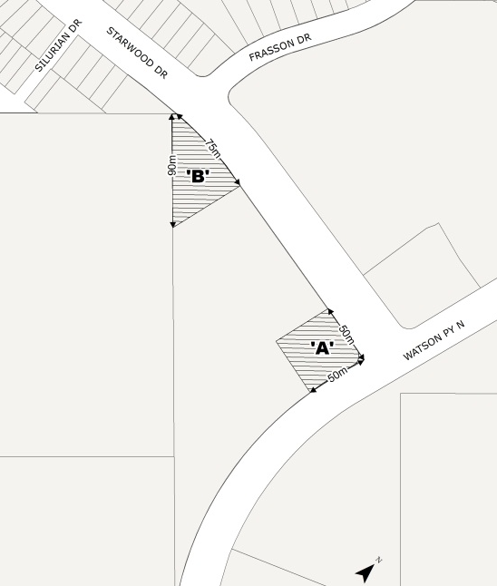

5.4.3.2.16.2.9 Floor Space Index (FSI)
The maximum Floor Space Index shall be 2.5

5.4.3.2.16.2.10 Location of Parking Areas
- Parking areas shall be permitted within 2 metres of a lot line
- No parking areas shall be located between a building façade and Starwood Drive or Watson Parkway North
- Underground parking spaces shall be permitted within 0.6 metre of a lot line

5.4.3.2.16.2.11 Minimum Landscaped Open Space
20% of the lot area

5.4.3.2.16.2.12 Minimum Common Amenity Area
11 square metres per unit

5.4.3.2.16.2.13 Regulations for Non-Residential Uses
- Buildings fronting on Starwood Drive within 120 metres of the intersecting street line projections at Starwood Drive and Watson Parkway North shall contain ground level non-residential uses.
- Buildings fronting on Starwood Drive within 50 metres of the intersecting street line projections at Starwood Drive and Watson Parkway North shall incorporate ground level commercial uses along Starwood Drive, exclusive of live/work units.
- Street Entrances to non-residential units shall be located facing Starwood Drive.
- The first storey of non-residential uses shall have a minimum ceiling height of 3.5 metres above grade.

5.4.3.2.16.2.14 Severability Provision
The provisions of this By-law shall continue to apply collectively to the whole of the subject lands in the R.4B-16 Zone, despite any future severance, conveyance, dedication, partition or division for any purpose.
5.4.3.2.16.2.15 No building, underground parking, surface parking, pool or any other impervious surface shall be constructed closer than 30m from the surveyed limit of the adjacent Provincially Significant Wetland.

5.4.3.2.16.2.16 Notwithstanding Section 5.4.3.2.16.1, the permitted uses within the 30m setback from the surveyed limit of the adjacent Provincially Significant Wetland shall be restricted to sod, groundcover, gardens, a walking path and passive common amenity area for condominium residents’ use, native tree plantings and other vegetation species ecologically suitable to the site.

5.4.3.2.16.2.17 Notwithstanding Row 15 of Table 5.4.2, where an R.4 Zone abuts a P.1 Zone the requirement for a buffer strip shall be satisfied by the provision of a permanent fence.

- Section 2.9.1 of By-law Number (1995)-14864, as amended, is hereby further amended by adding a new subsection 2.9.1 (xxvii):

2.9.1 (xxvii) (H27) 78 Starwood Drive – southerly portion (Defined Area Map 62)
Purpose
To ensure that development of the subject lands does not proceed until the following condition has been met to the satisfaction of the City.

Conditions
The necessary assembly or consolidation of any lands required to ensure orderly development and satisfactory driveway access in association with abutting developable lands with frontage on Watson Parkway North.

- Section 2.9.1 of By-law Number (1995)-14864, as amended, is hereby further amended by adding a new subsection 2.9.1 (xxviii):

2.9.1 (xxviii) (H28) 78 Starwood Drive – northerly portion (Defined Area Map 62)
Purpose
To ensure that development of the subject lands does not proceed until the following conditions have been met to the satisfaction of the City.

Conditions
- Make the necessary arrangements for the provision of the portion of future public road extension (land subject to H28) to connect with Starwood Drive.
- Sufficient assembly or consolidation of required abutting lands to facilitate orderly development and the future severance of lands to permit the development of full residential lots fronting on Starwood Drive in accordance with the zoning by-law
- Schedule ‘A’ of By-law Number (1995)-14864, as amended, is hereby further amended by deleting Defined Area Map 62 and substituting therefore a new Defined Area Map 62 attached hereto as Schedule “A”.

- This By-law is in force and effect on August 25, 2015, which is the date of the Ontario Municipal Board Order for file PL150062 as attached hereto.

- By-Law (2014)-19836 is hereby repealed.

IN FORCE AND EFFECT BY THE ONTARIO MUNICIPAL BOARD ORDER

FOR FILE PL150062 DATED AUGUST 25, 2015

Schedule “A”

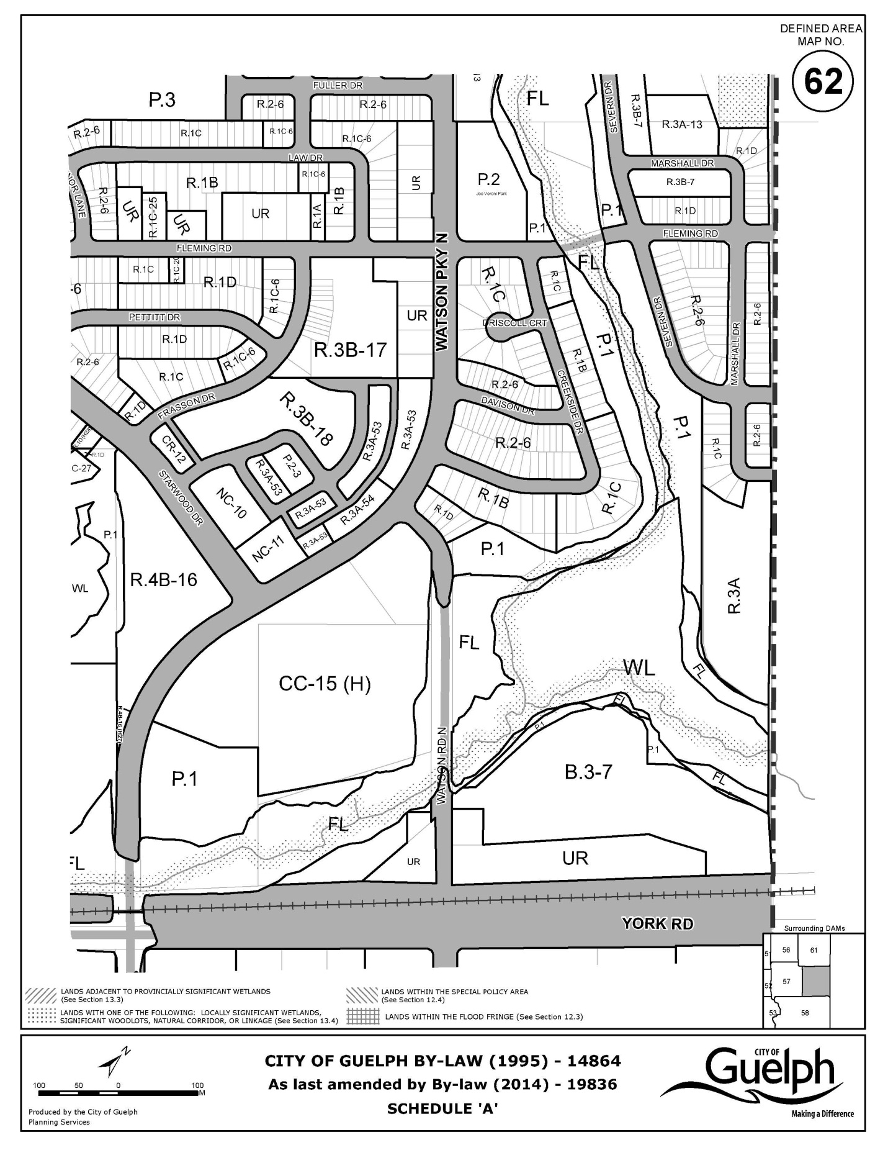
As Last Amended by By-law (2015)-19968

