THE CORPORATION OF THE CITY OF GUELPH

By-law Number (2013)-19630

A by-law to amend By-law Number (1995)-14864, as amended, known as the Zoning By-law for the City of Guelph as it affects property known municipally as 185-187 Bristol Street and legally described as Lot 18, Part Lot 19, Registered Plan 42, City of Guelph (ZC1216).

WHEREAS Section 34(1) of the Planning Act, R.S.O. 1990, c.P.13 authorizes the Council of a Municipality to enact Zoning By-laws;

NOW THEREFORE THE COUNCIL OF THE CORPORATION OF THE CITY OF GUELPH ENACTS AS FOLLOWS:

- By-law Number (1995)-14864, as amended, is hereby further amended by transferring property legally described as Lot 18, Part Lot 19, Registered Plan 42, City of Guelph and municipally known as 185-187 Bristol Street from the R.1B (Residential Single Detached) Zone to the R.4D-8 (Specialized Infill Apartment) Zone to permit an affordable housing project consisting of 9 supportive residential units.
- Section 5.4.3.4 of By-law Number (1995)-14864, as amended, is hereby further amended by adding a new subsection 5.4.3.4.8:

5.4.3.4.8 R.4D-8
185-187 Bristol Street
As shown on Defined Area Map Number 25 of Schedule “A” of this By-law.

5.4.3.4.8.1 Permitted Uses
- Supportive Housing
- Accessory Uses in accordance with Section 4.23

For the purposes of this Zone, Supportive Housing shall mean the use of a building with dwelling units to provide services and supports on-site that are designed to assist residents who need specific support services while allowing them to maintain a level of independence. Support services may include, but are not limited to, collective dining facilities, laundry facilities, counselling, educational services and life skills training.

5.4.3.4.8.2 Regulations
In accordance with the provisions of Section 4 (General Provisions), Section 5.4.3 and Table 5.4.2 of By-law Number (1995)-14864, as amended, with the following exceptions:

5.4.3.4.8.2.1 Maximum Number of Dwelling Units
9

5.4.3.4.8.2.2 Minimum Side Yard
2.5 metres

5.4.3.4.8.2.3 Off-Street Parking
A minimum of 7 parking spaces shall be provided

5.4.3.4.8.2.4 Parking Space Dimensions
The minimum exterior parking space dimensions shall be 2.5 metres by 5.5 metres for a maximum of 6 parking spaces

- Schedule ‘A’ of By-law Number (1995)-14864, as amended, is hereby further amended by deleting Defined Area Map 25 and substituting therefore a new Defined Area Map 25 attached hereto as Schedule “A”.
- Where notice of this by-law is given in accordance with the Planning Act, and where no notice of objection has been filed within the time prescribed by the Act, this by-law shall come into effect. Notwithstanding the above, where notice of objection has been filed within the time prescribed by the Act, no part of this by-law shall come into effect until all of such appeals have been finally disposed of by the Ontario Municipal Board.

PASSED this THIRTIETH day of SEPTEMBER, 2013.

__________________________________________

KAREN FARBRIDGE - MAYOR

__________________________________________

BLAIR LABELLE - CITY CLERK

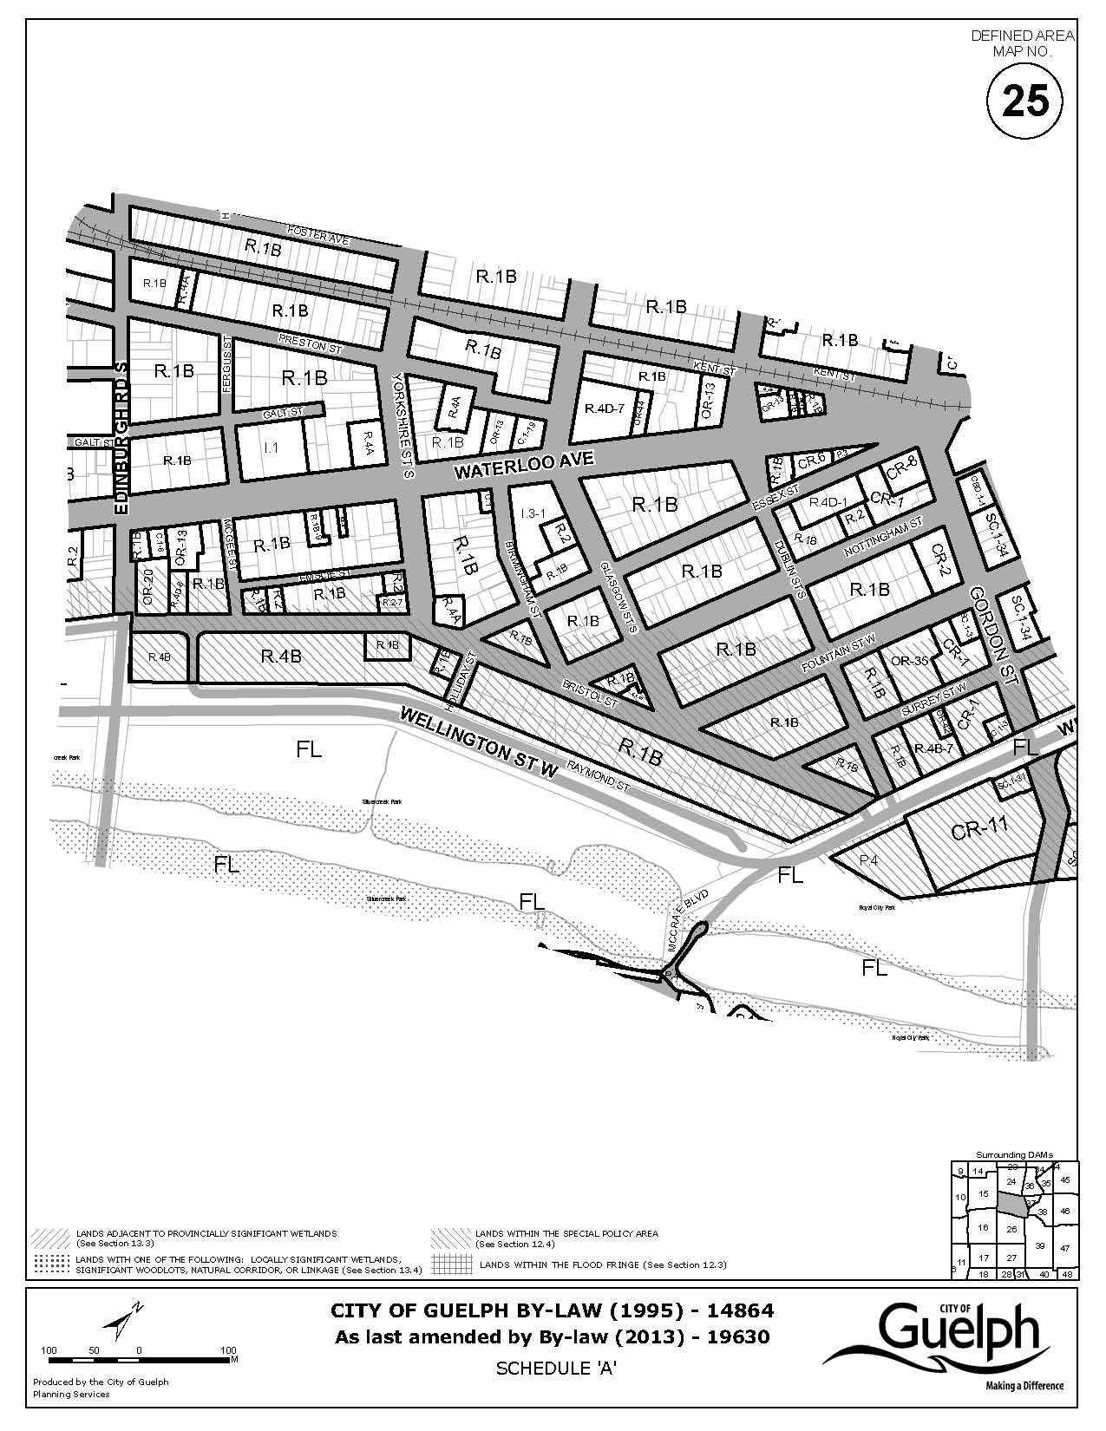

EXPLANATION OF PURPOSE AND EFFECT AND
KEY MAP FOR BY-LAW NUMBER (2013)-19630

1. By-law Number (2013)-19630 has the following purpose and effect:

This By-law authorizes a zoning by-law amendment affecting lands municipally known as 185-187 Bristol Street. The purpose of the proposed zoning by-law amendment is to rezone 185-187 Bristol Street from the R.1B (Single Detached Residential) Zone to the R.4D-8 (Specialized Apartment Infill) Zone to permit an affordable housing development consisting of 9 supportive residential units and accessory office space.

The proposed zoning by-law amendment was considered by Guelph City Council at a Public Meeting held on May 6, 2013 and was approved by Guelph City Council on September 9, 2013.

Further information may be obtained by contacting or visiting Planning Services, (519) 837-5616, extension 2360, City Hall, Guelph, Ontario.

Persons desiring to officially support or object to this zoning amendment must file their support or objection with the City Clerk, City Hall, Guelph, as outlined on the page entitled "Notice of Passing". Any comments or objections which you may have previously submitted are considered to have been unofficial and for the City's guidance only.

2. Key map showing the location of the lands to which By-law (2013)-19630 applies:

KEY MAP


