THE CORPORATION OF THE CITY OF GUELPH

By-law Number (2016)-20001

A by-law to amend the Official Plan for the City of Guelph as it affects property known municipally as 635 Woodlawn Road East and legally described as Part of Lot 2, Concession 6, Division “C”, (Geographic Township of Guelph), City of Guelph (File OP1105/ZC1118/23T-11503)(OMB order Case#PL140628, File #PL140628 on November 18, 2015).

WHEREAS the Ontario Municipal board issued an Order on November 18, 2015 for
File#PL140628 and Case#PL140628, to amend the City of Guelph By-law (1995)-14864 as amended, pursuant to Section 34(1) of the Planning Act, R.S.O.1990, c.P.13;

NOW THEREFORE THAT THE FOLLOWING BE ENACTED:
1. Amendment Number 59 to the Official Plan for the City of Guelph, as amended, consisting of the attached text and mapping (Schedule A) is hereby adopted by the Order of November 18, 2015.

IN FORCE AND EFFECT BY THE ONTARIO MUNICIPAL BOARD FOR
FILE #PL 140628, CASE #PL140628 DATED NOVEMBER 18, 2015.

AMENDMENT NO. 59

TO THE

OFFICIAL PLAN

FOR THE CITY OF GUELPH

AMENDMENT NO. 59
TO THE
OFFICIAL PLAN FOR THE CITY OF GUELPH

PART A - THE PREAMBLE The Preamble contains the rationale and certain background information in support of the amendment. The Preamble does not form part of this amendment.

PART B - THE AMENDMENT consists of the mapping changes introduced to the Official Plan for the City of Guelph through the Amendment.

PART A - THE PREAMBLE
PURPOSE
The purpose of Official Plan No. 59 is to add a site specific policy for the proposed apartment block as follows:

7.2.49 “In spite of the provisions of Policy 7.2.43, the development of an apartment block shall be permitted on lands municipally known as 635 Woodlawn Road East at not less than a minimum net density of 96 units per hectare.”

And:

To amend Schedule 1: ‘Land Use Plan’, Schedule 10: ‘Natural Heritage System: Natural Heritage System’ and Schedule 10A: ‘Natural Heritage System: ANSIs and Wetlands’ for the property known municipally as 635 Woodlawn Road East. Changes on Schedule 1: ‘Land Use Plan’ will re-designate the land uses on the property from “General Residential” and “Core Greenlands” with a “Non-Core Greenlands Overlay” to the “General Residential”, “High Density Residential”, “Commercial Mixed Use”, “Open Space” and “Significant Natural Areas & Natural Areas” land use designations. Modifications to Schedule 10: ‘Natural Heritage System: Natural Heritage System’ will have the effect of refining the boundaries of the “Restoration Areas” located within the “Significant Natural Areas & Natural Areas” land use designation on this property. Modifications to Schedule 10A: ‘Natural Heritage System: ANSIs and Wetlands’ will have the effect of refining the boundaries and buffers of “Provincially Significant Wetlands”.

LOCATION
The subject property affected by this proposed amendment is known municipally as 635 Woodlawn Road East and is bounded by Woodlawn Road to the north, Eramosa Road to the south, existing residential dwelling units located off of Muskoka Drive and Brant Avenue to the west and the Township of Guelph Eramosa to the East (see Location Map below).
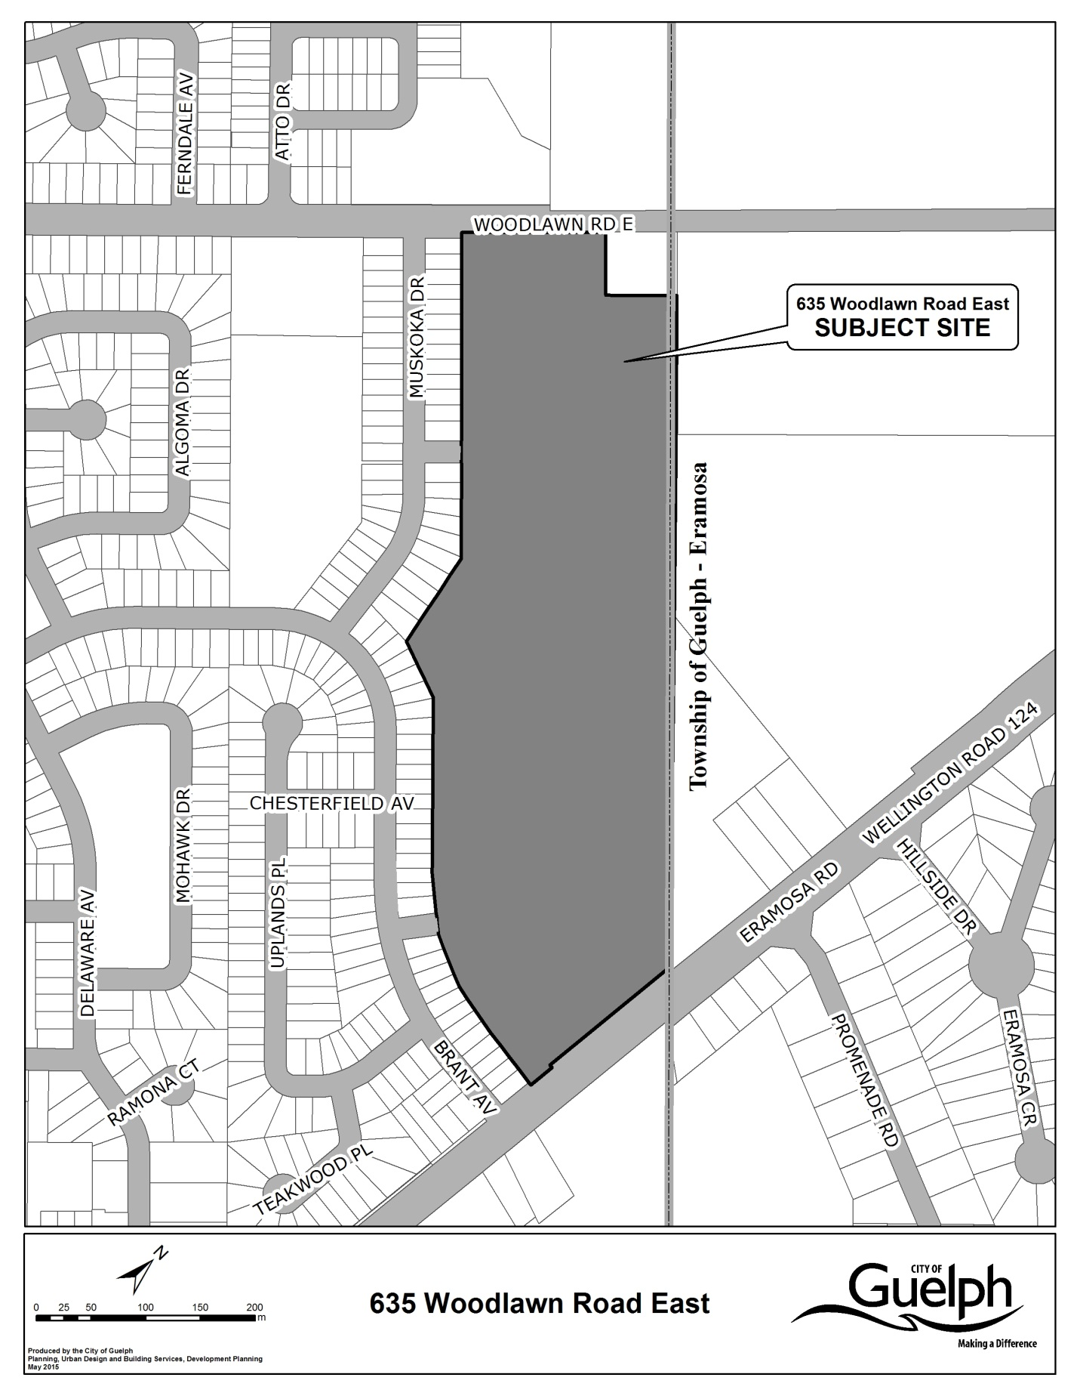

BASIS

The subject property has a site area of approximately 14.723 hectares and has a driveway access from Woodlawn Road East. Adjacent land uses consist of Woodlawn Road to the north, beyond which are residential uses, residential uses to the west (located on Muskoka Drive and Brant Avenue), rural residential and lands owned by the Grand River Conservation Authority to the east (in the Township of Guelph-Eramosa), and Eramosa Road to the south.
The Developer submitted this Official Plan Amendment in conjunction with an application to amend the Zoning By-law and an application for Draft Plan of Subdivision. The applications were deemed to be ‘complete’ on December 18, 2011. The applications were presented at a Public Meeting held on June 5, 2012.
On June 12, 2014, the Developer appealed the Draft Plan of Subdivision, Official Plan Amendment and Zoning By-law Amendment applications to the Ontario Municipal Board (OMB) for non-decision within the prescribed time under the Planning Act. The City and Developer have chosen to pursue a settlement based on a draft plan that differs from the June 5 Statutory Public Meeting. The “Alternative Design Proposal” will allow the development of 117 single detached dwellings, 4 semi-detached units, 66 apartment units, 61 on-street townhouse units, 86 residential units within mixed use buildings including office and commercial uses.
The Official Plan Amendment will re-designate the subject property to the “General Residential”, “High Density Residential”, “Commercial Mixed Use”, “Open Space” and “Significant Natural Areas & Natural Areas” land use designations. Schedule 1 - `Land Use Plan’, Schedule 10 - `Natural Heritage System’ and Schedule 10A - `Natural Heritage System – ANSIs and Wetlands’ will all be amended to reflect the Official Plan Amendment.
The Developer is proposing a mix of single detached dwellings, semi-detached dwellings and townhouses and has therefore requested that these lots and blocks remain within the “General Residential” land use designation. The predominant use of land in areas designated, as “General Residential” is residential. All forms of residential development is permitted in conformity with the policies of this designation. The general character of development will be low-rise housing

forms. The net density of development is not to exceed 100 units per hectare (40 units/acre) within the “General Residential” land use designation (Policy 7.2.32). The proposed density is 34.42 units/hectare.
The Developer is proposing an apartment block consisting of 66 units and has requested that this block be re-designated to “High Density Residential”. The predominant use of land within this designation is multiple unit residential buildings, generally in the form of apartments (Policy 7.2.41). The net density of development in this designation shall not occur at less than 100 units per hectare (40 units/acre) and shall not exceed 150 units per hectare (61 units/acre). The proposed density is 97.34 units/hectare. A site specific policy will be added to the Official Plan to reflect the proposed density on the apartment block.
The Developer is proposing commercial/office/residential blocks and has requested the “Commercial Mixed Use” land use designation for these blocks. New development proposals within the “Commercial Mixed Use” designation are permitted in consideration of the following general criteria:
- The building design should have a street orientation, promote continuity in the streetscape and adhere to the urban design policies of subsection;
- In instances where residential units are proposed, the maximum net density shall not exceed 100 units per hectare and the development criteria of policy 7.2.7 will be used to assess compatibility;
- Adequate parking, loading and access are required;
- Adequate municipal services are required; and
- Lot development and building
The implementing Zoning By-law will regulate the permitted uses and setbacks for these blocks.
The proposed park block will be designated as “Open Space” in conformity with the “Open Space” land use designation. The predominant use of land designated “Open Space” is for public and private recreational uses and facilities, parks, golf courses, conservation lands, school sites, and cemeteries. The designation is also intended to support the protection of natural heritage features and cultural heritage resource conservation (Policy 7.12.1).
The Wetlands, Buffers and Stormwater Management Blocks will be designated “Significant

Natural Areas and Natural Areas” through this Official Plan Amendment. The “Significant Natural Areas” designation includes:
a. Significant Areas of Natural and Scientific Interest (ANSI),
b. Significant Habitat for Provincially Endangered and Threatened Species,
c. Significant Wetlands,
d. Surface Water Features and Fish Habitat,
e. Significant Woodlands,
f. Significant Valleylands,
g. Significant Landform,
h. Significant Wildlife Habitat (including Ecological Linkages),
i. Restoration Areas, and
j. Minimum or established buffers (where applicable).
The “Natural Areas” designation includes:
a. Other Wetlands,
b. Cultural Woodlands
c. Habitat of Significant Species, and
d. Established buffers (where applicable).
Official Plan Schedule 10: Natural Heritage System will be modified to further refine the “Significant Natural Areas” designation to “Significant Natural Areas” (for Wetlands and buffers) and to “Restoration Areas” (for Stormwater Management).
Official Plan Schedule 10A: Natural Heritage System – ANSIs and Wetlands will be modified to further refine the boundaries of the Provincially Significant Wetland (as identified by the MNRF).
The Zoning By-law amendment will implement the draft plan of subdivision and will be in conformity with the Official Plan land use designations being proposed. Staff are satisfied that the proposed amendment is consistent with the goals and objectives of the Official Plan.

PART B - THE AMENDMENT
All of this section entitled “Part B – The Amendment,” constitutes Amendment No. 59 to the Official Plan for the City of Guelph.
Details of the Amendment
The Official Plan for the City of Guelph is amended as follows:
By adding the following policy to the Official Plan for the City of Guelph:
7.2.49 “In spite of the provisions of Policy 7.2.43, the development of an apartment block shall be permitted on lands municipally known as 635 Woodlawn Road East at not less than a minimum net density of 96 units per hectare.”

And:
By amending Schedule 1: ‘Land Use Plan, by modifying Schedule 10: ‘Natural Heritage System: Natural Heritage System’ and Schedule 10A: ‘Natural Heritage System: ANSIs and Wetlands’ for the property known municipally as 635 Woodlawn Road East.
The amendment to Schedule 1: ‘Land Use Plan’ will re-designate the land uses on the property from “General Residential” and “Core Greenlands” with a “Non-Core Greenlands Overlay” to the “General Residential”, “High Density Residential”, “Commercial Mixed Use”, “Open Space” and “Significant Natural Areas & Natural Areas” land use designations. The modifications to Schedule 10: ‘Natural Heritage System: Natural Heritage System’ will have the effect of refining the boundaries of the “Restoration Areas” located within the “Significant Natural Areas & Natural Areas” land use designation on this property. The modifications to Schedule 10A: ‘Natural Heritage System: ANSIs and Wetlands’ will have the effect of refining “Provincially Significant Wetlands” boundaries and their buffers.

Amend Schedule 1, Land Use Plan of the Official Plan by changing the land use designation on the property municipally known as 635 Woodlawn Road East, from the “General Residential” and “Core Greenlands” with a “Non-Core Greenlands Overlay to the “General Residential”, “High Density Residential”, “Commercial Mixed Use”, “Open Space” and “Significant Natural Areas & Natural Areas” land use designations.

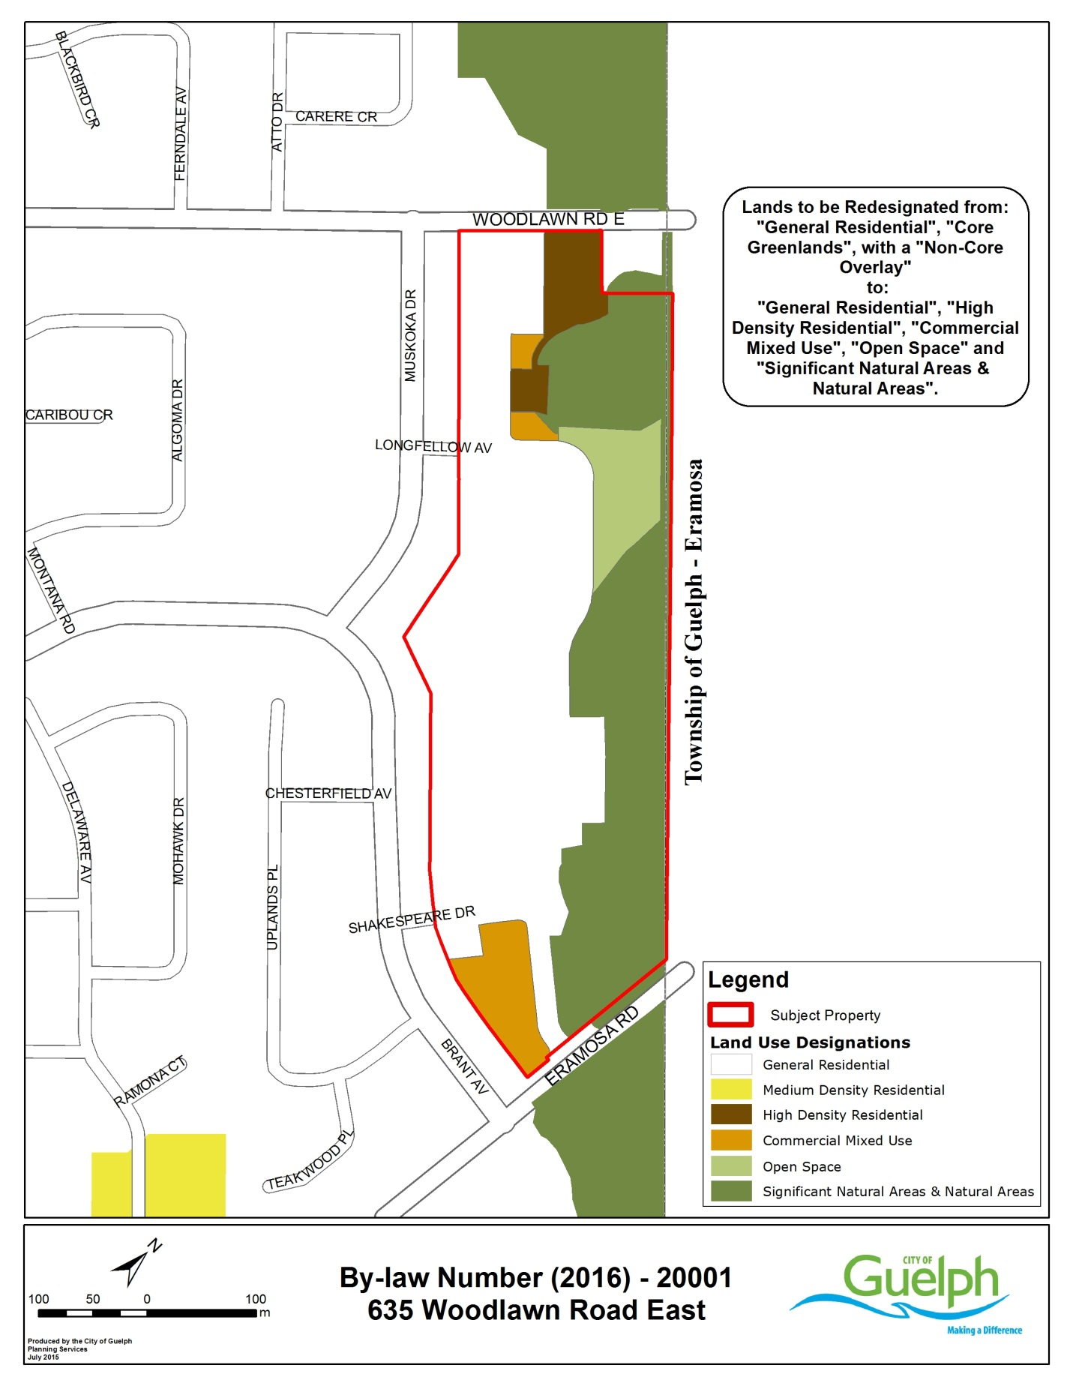

Modify Schedule 10: ‘Natural Heritage System: Natural Heritage System’ of the Official Plan for the property municipally known as 635 Woodlawn Road East to refine the boundaries of the “Restoration Areas” located within the “Significant Natural Areas & Natural Areas” land use designation on this property.
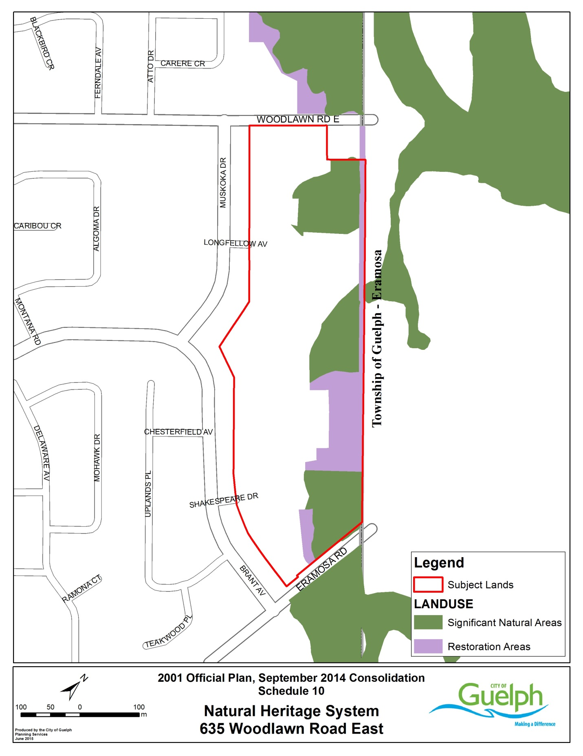

Modify Schedule 10A: ‘Natural Heritage System: ANSIs and Wetlands’ of the Official Plan for the property municipally known as 635 Woodlawn Road East to refine the boundaries and buffers of the “Provincially Significant Wetlands” on this property.



