THE CORPORATION OF THE CITY OF GUELPH

By-law Number (2013)-19674

A by-law to amend By-law Number (1995)-14864, as amended, known as the Zoning By-law for the City of Guelph as it affects property known municipally as 180 Gordon Street and legally described as Part of Lot A, Plan 302, City of Guelph to permit the development of townhouses (ZC1107) (OMB file PL120457)and to repeal By-law (2012)-19352.

WHEREAS the Ontario Municipal Board issued an Order PL120457 on July 26, 2013, to Amend the City of Guelph By-Law (1995)-14864 as amended, pursuant Section 34(1) of the Planning Act, R.S.O. 1990, c.P.13;

NOW THEREFORE THAT THE FOLLOWING BE ENACTED:

- By-law Number (1995)-14864, as amended, is hereby further amended by transferring property legally described as Part of Lot A, Plan 302, City of Guelph and municipally known as 180 Gordon Street from the C.1-19 (Convenience Commercial) Zone and FL (Floodway) Zone to a new Specialized R.3A (Townhouse) Zone, to be known as the R.3A-47 Zone, to permit the development of townhouses.
- Section 5.3.3.1 of By-law Number (1995)-14864, as amended, is hereby further amended by adding a new subsection 5.3.3.1.47:
5.3.3.1.47 R.3A-47 (H)
180 Gordon Street
As shown on Defined Area Map Number 39 of Schedule “A” of this By-law.
5.3.3.1.47.1 Permitted Uses
- Cluster Townhouse
- Home Occupation in accordance with Section 4.19
- Accessory Use in accordance with Section 4.23
5.3.3.1.47.2 Regulations
In accordance with the provisions of Section 5.3.2 of Zoning By-law (1995)-14864, as amended, with the following exceptions and additions:
5.3.3.1.47.2.1 Lot Area Per Dwelling Unit
Notwithstanding the provisions of Table 5.3.2, Row 3, the minimum lot area per dwelling unit shall be 143 square metres.
5.3.3.1.47.2.2 Side Yard
Notwithstanding the provisions of Table 5.3.2, Row 6 and the provisions of Section 5.3.2.2, no building shall be located closer to any side lot line than 3 metres.
5.3.3.1.47.2.3 Rear Yard
Notwithstanding the provisions of Table 5.3.2, Rows 7 and the provisions of Section 5.3.2.2, no building or structure shall be located closer to any rear lot line than 3 metres.
5.3.3.1.47.2.4 Building Coverage
Notwithstanding the provisions of Table 5.3.2, Row 8, the maximum building coverage shall be 46% of the lot area.
5.3.3.1.47.2.5 Maximum Building Height
Notwithstanding the provisions of Table 5.3.2, Row 9, the maximum building height shall be:
- 4 storeys provided that the gross floor area of the fourth storey shall be limited to a maximum of 165 square metres in total and shall not contain any habitable floor space.
- Section 4.16 shall not be applicable.
- in accordance with Section 4.18.

5.3.3.1.47.2.6 Angular Plane
Notwithstanding the provisions of Table 5.3.2, Row 9 and Section 4.16, the angular plane that applies to the side lot line adjacent to the Park shall be a maximum of 82 degrees.

5.3.3.1.47.2.7 Landscaped Open Space
Notwithstanding the provisions of Table 5.3.2, Row 13, the minimum landscaped open space shall be 17% of the lot area.
5.3.3.1.47.2.8 Off-Street Parking Location
In accordance with the provisions of Table 5.3.2, Row 16 and the provisions of Section 4.13, with the following exceptions:
- Notwithstanding the provisions of Sections 4.13.2.2 and 4.13.2.2.1, every parking space shall be located in the side or rear yard provided that no parking space is located within 0.3 metres of any lot line with the following exception:
  - A maximum of 2 visitor parking spaces, or parts thereof, may be located within required front yard.
- Notwithstanding the provisions of Section 4.13.2.2.2, no part of any surface driveway or surface parking area shall be located within 1.0 metre of a building entrance or any window of a habitable room.
5.3.3.1.47.2.9 Accessory Buildings or Structures
In accordance with the provisions of Table 5.3.2, Row 17 and the provisions of Section 4.5, with the following exceptions:
- Notwithstanding the provisions of Section 4.5.1.2 and 5.3.3.1.47.2.2, the minimum side yard setback to an accessory structure shall be 0.3 metres.
- Notwithstanding the provisions of Section 4.5.1.4, the maximum gross floor area of all accessory buildings or structures shall not exceed 173 square metres.
5.3.3.1.47.2.10 Density
Notwithstanding the provisions of Table 5.3.2, Row 20 and the provisions of Section 5.3.2.6, the maximum density shall be 59 units per hectare.
5.3.3.1.47.3 Holding Provision R.3A-47 (H) Zone
Purpose
To ensure that the property to be developed is remediated to meet the Site Condition Standards of the intended residential land use.

Permitted Interim Uses
Those uses permitted by the C.1-19 (Convenience Commercial) Zone:
- Vehicle Service Station including accessory sales of motor vehicles
Holding Provision Conditions
Prior to the removal of the Holding provision (H), the owner shall:
- Submit all environmental site assessment, risk assessment, remediation and monitoring reports prepared in accordance with the Records of Site Condition regulation (O. Reg 153/04 as amended) describing the current conditions of the property known municipally as 180 Gordon Street to the satisfaction of the City;
- File a Record of Site Condition (RSC) on the Ministry of the Environment (MOE) Environmental Site Registry for the property including certification by a Qualified Person as defined by O.Reg. 153/04 as amended that the environmental condition of the property meets the appropriate MOE Site Condition Standards for the intended land use; and,
- Submit the MOE acknowledgment letter for the RSC to the satisfaction of the City.
- Schedule ‘A’ of By-law Number (1995)-14864, as amended, is hereby further amended by deleting Defined Area Map 39 and substituting therefore a new Defined Area Map 39 attached hereto as Schedule “A”.
- This By-law is in force and effect on July 26, 2013, which is the date of the Ontario Municipal Board Order PL120457 (OMB file # PL120458) as attached hereto.

IN FORCE AND EFFECT BY ONTARIO MUNICIPAL ORDER ON JULY 26, 2013; FILE NUMBER PL120457

Schedule ‘A’

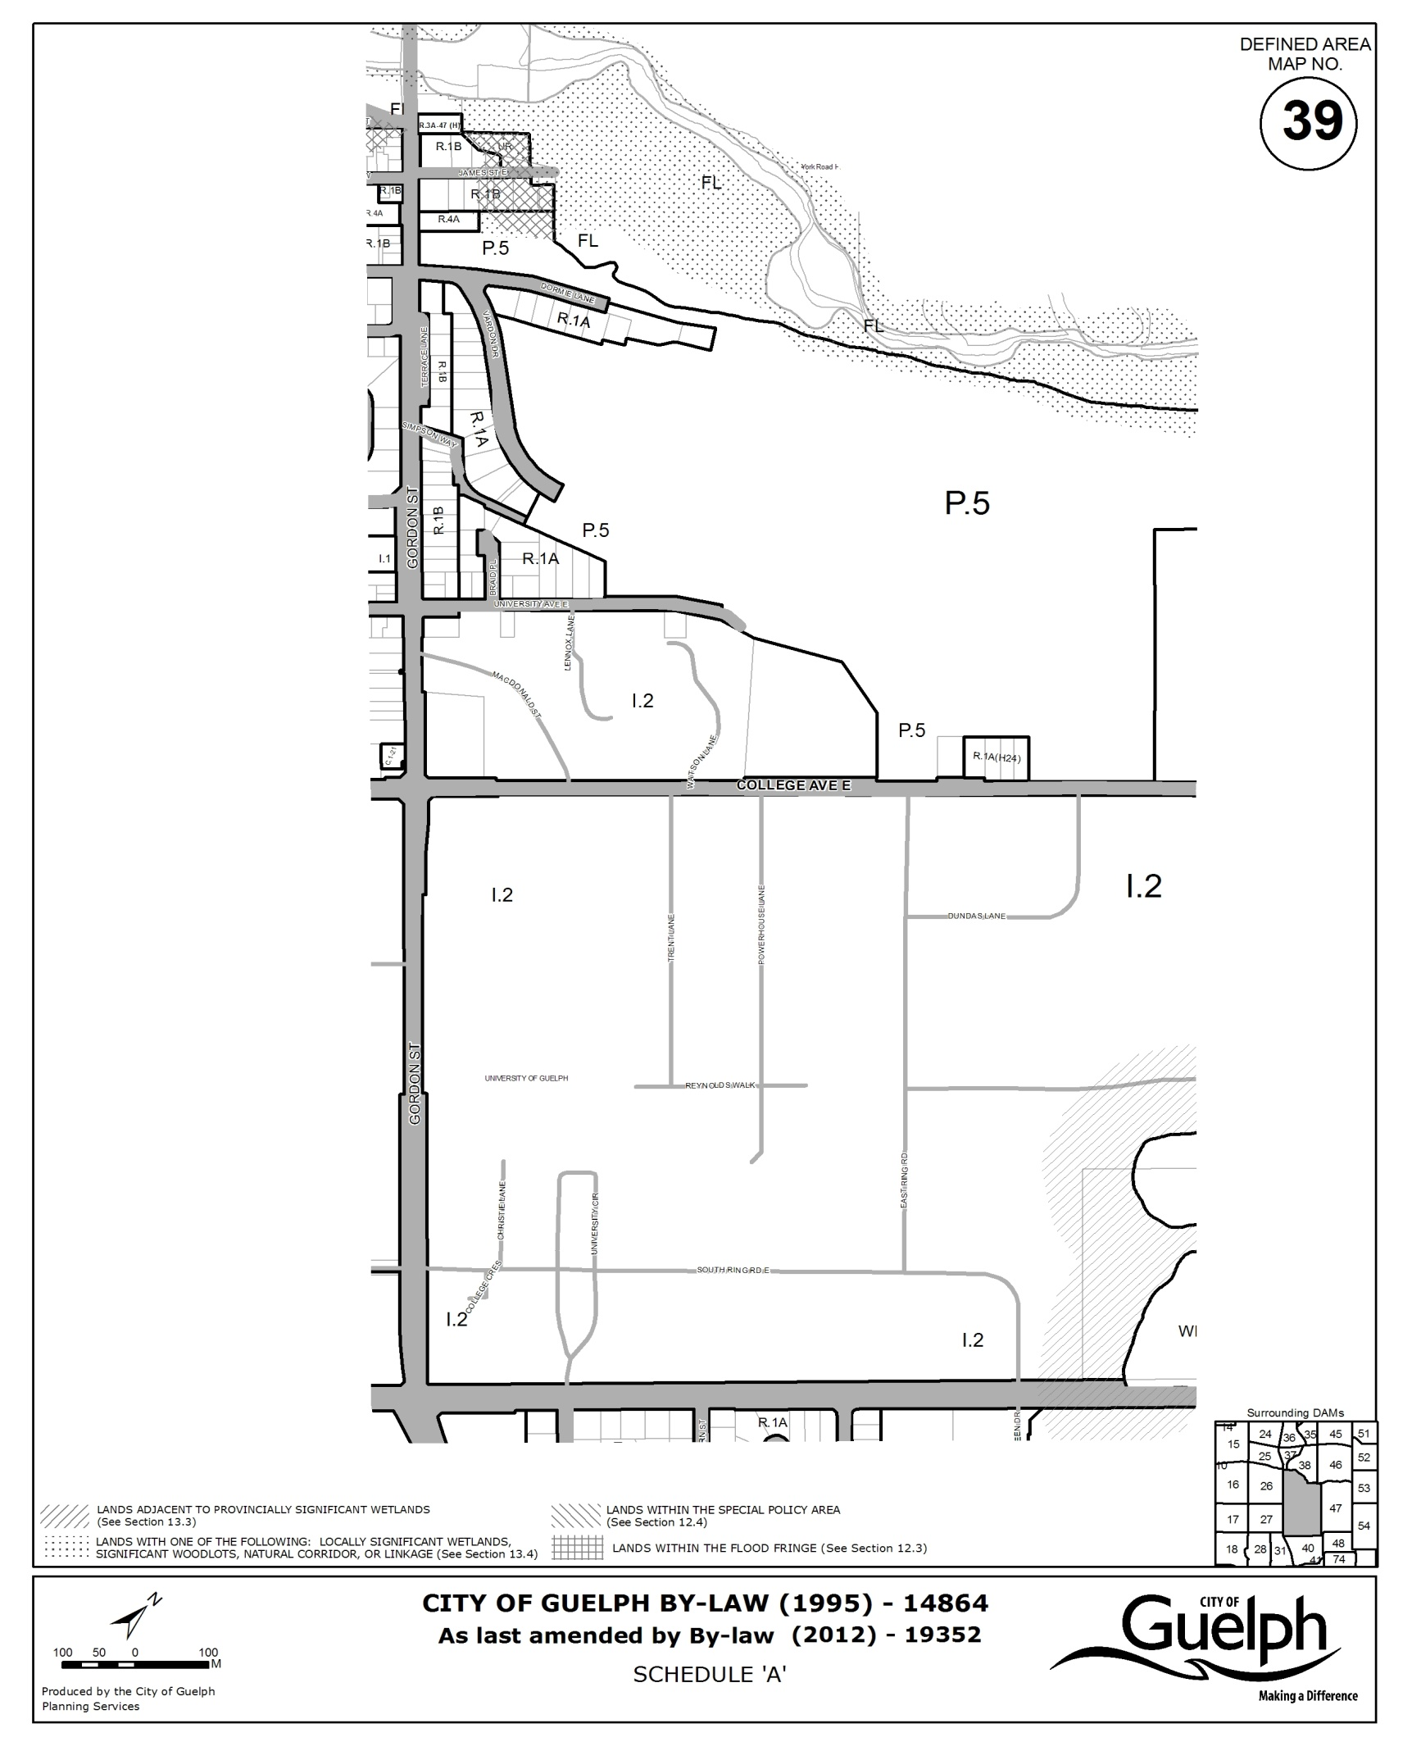
As last amended by By-law (2013)-19674

EXPLANATION OF PURPOSE AND EFFECT AND
KEY MAP FOR BY-LAW NUMBER (2013)-19674

1. By-law Number (2013)-19674 has the following purpose and effect:

This By-law authorizes a zoning by-law amendment affecting lands municipally known as 180 Gordon Street. The purpose of the proposed zoning by-law amendment is to rezone the property from the current C.1-19 (Convenience Commercial) Zone and FL (Floodway) Zone to the Specialized R.3A-47 (Townhouse) Zone. The effect of the proposed zoning by-law amendment is to permit the development of townhouses.

The proposed zoning by-law amendment was considered by Guelph City Council at Public Meetings held on May 3, 2011, October 3, 2011 and February 6, 2012 and was approved by Guelph City Council on March 5, 2012.

Further information may be obtained by contacting or visiting Planning and Building Services, (519) 837-5616, extension 2327, City Hall, Guelph, Ontario.

Persons desiring to officially support or object to this zoning amendment must file their support or objection with the City Clerk, City Hall, Guelph, as outlined on the page entitled "Notice of Passing". Any comments or objections which you may have previously submitted are considered to have been unofficial and for the City's guidance only.

2. Key map showing the location of the lands to which By-law (2013)-19674 applies:

KEY MAP
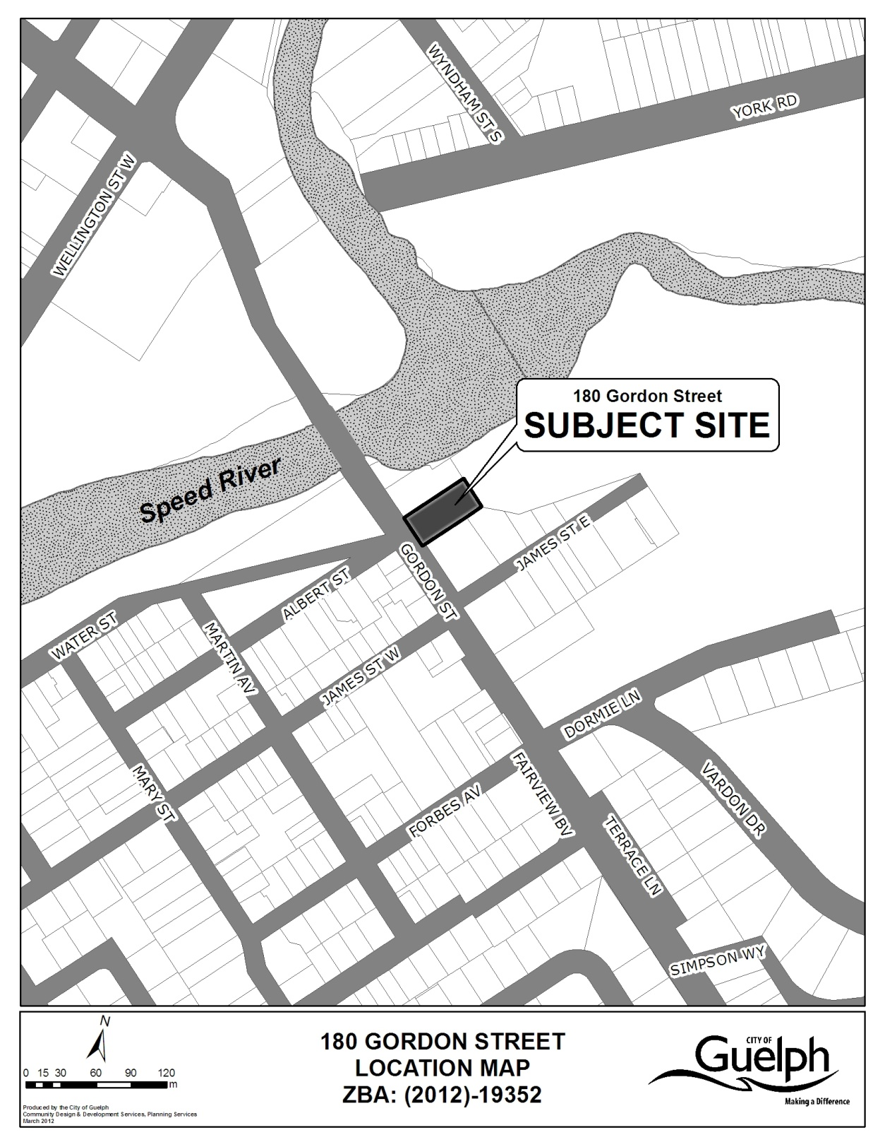
By-Law (2013)-19674

