THE CORPORATION OF THE CITY OF GUELPH

By-law Number (2013)-19677

A by-law to amend the Official Plan for the City of Guelph as it affects property known municipally as 716 Gordon Street and legally described as Part of Block A, Registered Plan 552, City of Guelph (OP1001) (OMB File PL111340)

WHEREAS the Ontario Municipal Board issued an order PL111340 on August 29, 2013 to amend the City of Guelph Official Plan, as amended, pursuant to Section 17 of the Planning Act, R.S.O. 1990;

NOW THEREFORE THAT THE FOLLOWING BE ENACTED:

1. Amendment Number 53 to the Official Plan for the City of Guelph, as amended, consisting of the attached Preamble (Schedule A) mapping (Schedule B) and text (Schedule C) is hereby adopted.

2. This by-law is in force and effect on August 29, 2013, which is the date of the Ontario Municipal Board Order PL 111340 as attached hereto.

IN FORCE AND EFFECT BY ONTARIO MUNICIPAL BOARD ORDER ON AUGUST 29, 2013; FILE NUMBER PL111340.

Schedule ‘A’

The Preamble

Purpose of the Amendment:
The purpose of the Amendment is to redesignate lands from the “General Residential” designation to the “High Density Residential” designation to permit the development of a high density apartment development subject to a site specific policy (7.2.48) that permits the maximum density of the property at 716 Gordon Street to be 156 units per hectare.

Location:
The lands subject to this Amendment, as indicated on the attached Schedule “B” are municipally known as 716 Gordon Street, and legally described as Part of Block A, Registered Plan 552, City of Guelph.

Basis:
The applicant requested an amendment to the City of Guelph Official Plan to permit an apartment development with a maximum density of 156 units per hectare in lieu of the standard maximum of 150 units per hectare allowed in the high density residential designation as per policy 7.2.43. Further information can be found in the Ontario Municipal Board Order on OMB File No. PL111340) dated April 22, 2013.

Schedule ‘B’
Official Plan Amendment #53
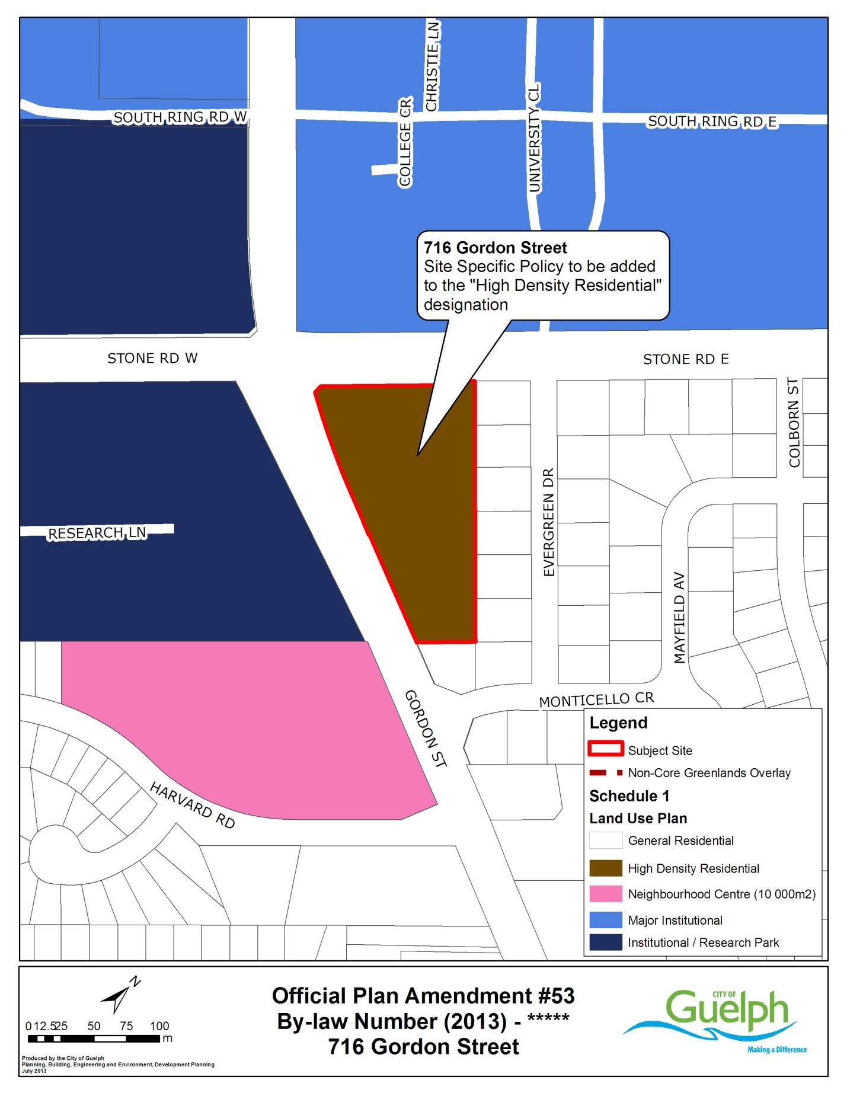
Schedule ‘C’
19677

Official Plan Amendment #53

Amend Schedule 1, Land Use Plan of the Official Plan by changing the land use designation of the property municipally known as 716 Gordon Street from the current “General Residential” designation to the “High Density Residential” designation.

Amend the Official Plan text by the addition of a new site specific sub-policy for the property municipally known as 716 Gordon Street. Amend Section 7.2 of the Official Plan, “Residential”, by adding Official Plan Policy 7.2.48 with the following clause:

7.2.48 In spite of the maximum density provisions of Policy 7.2.43, the density of residential development on the lands known municipally as 716 Gordon Street shall be permitted to occur at a maximum density of 156 units per hectare.

