THE CORPORATION OF THE CITY OF GUELPH

By-law Number (2012)-19475

A by-law to amend By-law Number (1995)-14864, as amended, known as the Zoning By-law for the City of Guelph, to implement Phase 3 of the Kortright East Subdivision on lands municipally known as 927 and 1023 Victoria Road South.

WHEREAS Section 34(1) of The Planning Act, R.S.O. 1990, c.P.13 authorizes the Council of a Municipality to enact Zoning By-laws;

NOW THEREFORE THE COUNCIL OF THE CORPORATION OF THE CITY OF GUELPH ENACTS AS FOLLOWS:

- By-law Number (1995)-14864, as amended, is hereby further amended by transferring property legally described as Part of Lots 3 and 4, Concession 8, formerly Geographic Township of Puslinch now in the City of Guelph, municipally known as 927 and 1023 Victoria Road South in the City of Guelph, from the Township of Puslinch A (Agriculture) Zone and H (Hazard) Zone to a new Specialized R.1B-43 (Single-detached Residential) Zone, the R.1C (Single-detached Residential) Zone, the R.1D (Single-detached Residential) Zone, a new Specialized R.1D-43 (Single-detached Residential) Zone, a new Specialized R.2-20 (Semi-detached Residential) Zone, a new Specialized R.2-21 (Semi-detached Residential) Zone, the existing Specialized R.3B-7 (On-Street Townhouse) Zone, the P.1 (Conservation Land / Park) Zone, the P.2 (Neighbourhood Park) Zone and the WL (Wetland) Zone, to implement Phase 3 of the Kortright East Subdivision in accordance with the following zoning schedule:

Zone | Specialized Regulations | Lot/Block
Specialized R.1B-43 (Single Detached Residential) | - minimum lot area of 390m² where 460m² is required  - minimum side yard of 1.2m where 1.5m is required | Lots 1-8, 57-85
R.1C (Single Detached Residential) |  | Lots 86-94
R.1D (Single Detached Residential) |  | Lots 95-134, 144-150
Specialized R.1D-43 (Single Detached Residential) | - minimum front yard setback of 4.5m where 6m is required  - minimum front yard setback of 6m to the front wall of garage | Lots 9-17, 29-34, 44-48, 51-56
Specialized R.2-20 (Semi-detached Residential) | - minimum lot area of 448m² where 460m^{2,} is required and minimum lot area per unit of 224m² when 230m² is required  - minimum lot frontage of 13.7m and minimum lot frontage per unit of 6.8m when 15m is required in total, and 7.5m is required per unit.  - minimum front yard setback of 4.5m where a minimum of 6m is required  - increased maximum building coverage to 50% where 40% is permitted,  - increased driveway width to 50% of the front yard where whereas the maximum is 40% | Lots 18-28,35-43, 49-50
Specialized R.2-21 (Semi-detached Residential) | - increased driveway width to 50% of the front yard where whereas the maximum is 40% | Lots 135-143
Specialized R.3B-7 (Residential Townhouse) | - increased maximum building coverage of 50% | Blocks 151-157
P.1 (Conservation Land) |  | Blocks 159-166
P.2 (Neighbourhood Park) |  | Block 158
WL (Wetland) |  | Part Block 164

- Section 5.1.3.2 of By-law Number (1995)–14864, as amended, is hereby further amended by adding a new subsection 5.1.3.2.43:
“5.1.3.2.43 R.1B-43
927 Victoria Road South
As shown on Defined Area Map Number 74 of Schedule “A” of this Bylaw.

5.1.3.2.43.1 Permitted Uses
In accordance with Section 5.1.1 of Zoning By-law (1995) – 14864, as amended.

5.1.3.2.43.2 Regulations
In accordance with Section 5.1.2 of Zoning By-law (1995) – 14864, as amended, with the following exceptions:

5.1.3.2.43.2.1 Minimum Lot Area
Despite Table 5.1.2, Row 3, the minimum lot area shall be 390m2.

5.1.3.2.43.2.2 Minimum Side Yard
Despite Table 5.1.2, Row 7, the minimum side yard shall be 1.2m.”

- Section 5.1.3.4 of By-law Number (1995)–14864, as amended, is hereby further amended by adding a new subsection 5.1.3.4.43:
“5.1.3.4.43 R.1D-43
1023 Victoria Road South
As shown on Defined Area Map Number 74 of Schedule “A” of this Bylaw.

5.1.3.4.43.1 Permitted Uses
In accordance with Section 5.1.1 of Zoning By-law (1995) – 14864, as amended.

5.1.3.4.43.2 Regulations
In accordance with Section 5.1.2 of Zoning By-law (1995) – 14864, as amended, with the following exception:

5.1.3.4.43.2.1 Minimum Front Yard
Despite Table 5.1.2, Row 6, the minimum front yard shall be 4.5m for habitable floor space and 6m to the front wall of a garage.”

- Section 5.2.3 of By-law Number (1995)–14864, as amended, is hereby further amended by adding a new subsection 5.2.3.20:
“5.2.3.20 R.2-20
1023 Victoria Road South
As shown on Defined Area Map Number 74 of Schedule “A” of this Bylaw.

5.2.3.20.1 Permitted Uses
In accordance with Section 5.2.1 of Zoning By-law (1995) – 14864, as amended.

5.2.3.20.2 Regulations
In accordance with Section 5.2.2 of Zoning By-law (1995) – 14864, as amended, with the following exceptions:

5.2.3.20.2.1 Minimum Lot Area
Despite Table 5.2.2, Row 2, the minimum lot area for every two units shall be 448m2 and the minimum lot area for each unit shall be 224m2.

5.2.3.20.2.2 Minimum Lot Frontage
Despite Table 5.2.2, Row 3, the minimum lot frontage for every two units shall be 13.7m and the minimum lot frontage for each unit shall be 6.8m.

5.2.3.20.2.3 Minimum Front Yard
Despite Table 5.2.2, Row 5, the minimum front yard shall be 4.5m.

5.2.3.20.2.4 Maximum Lot Coverage
Despite Table 5.2.2, Row 11, the maximum lot coverage shall be 50% of the lot area.

5.2.3.20.2.5 Minimum Landscaped Open Space
Despite Table 5.2.2, Row 15, the maximum driveway width shall be 50% of the front yard.”

- Section 5.2.3 of By-law Number (1995)–14864, as amended, is hereby further amended by adding a new subsection 5.2.3.21:
“5.2.3.21 R.2-21
927 Victoria Road South
As shown on Defined Area Map Number 74 of Schedule “A” of this Bylaw.

5.2.3.21.1 Permitted Uses
In accordance with Section 5.2.1 of Zoning By-law (1995) – 14864, as amended.

5.2.3.21.2 Regulations
In accordance with Section 5.2.2 of Zoning By-law (1995) – 14864, as amended, with the following exception:

5.2.3.21.2.1 Minimum Landscaped Open Space
Despite Table 5.2.2, Row 15, the maximum driveway width shall be 50% of the front yard.”

- Schedule “A” of By-law Number (1995)-14864, as amended, is hereby further amended by deleting Defined Area Map 74 and substituting therefore a new Defined Area Map 74 attached hereto as Schedule “A”.

- Where notice of this by-law is given in accordance with the Planning Act, and where no notice of objection has been filed within the time prescribed by the regulations, this by-law shall come into effect. Notwithstanding the above, where notice of objection has been filed within the time prescribed by the regulations, no part of this by-law shall come into effect until all of such appeals have been finally disposed of by the Ontario Municipal Board.

PASSED this TWENTY-SECOND day of OCTOBER, 2012.

__________________________________________

KAREN FARBRIDGE - MAYOR

__________________________________________

BLAIR LABELLE - CITY CLERK

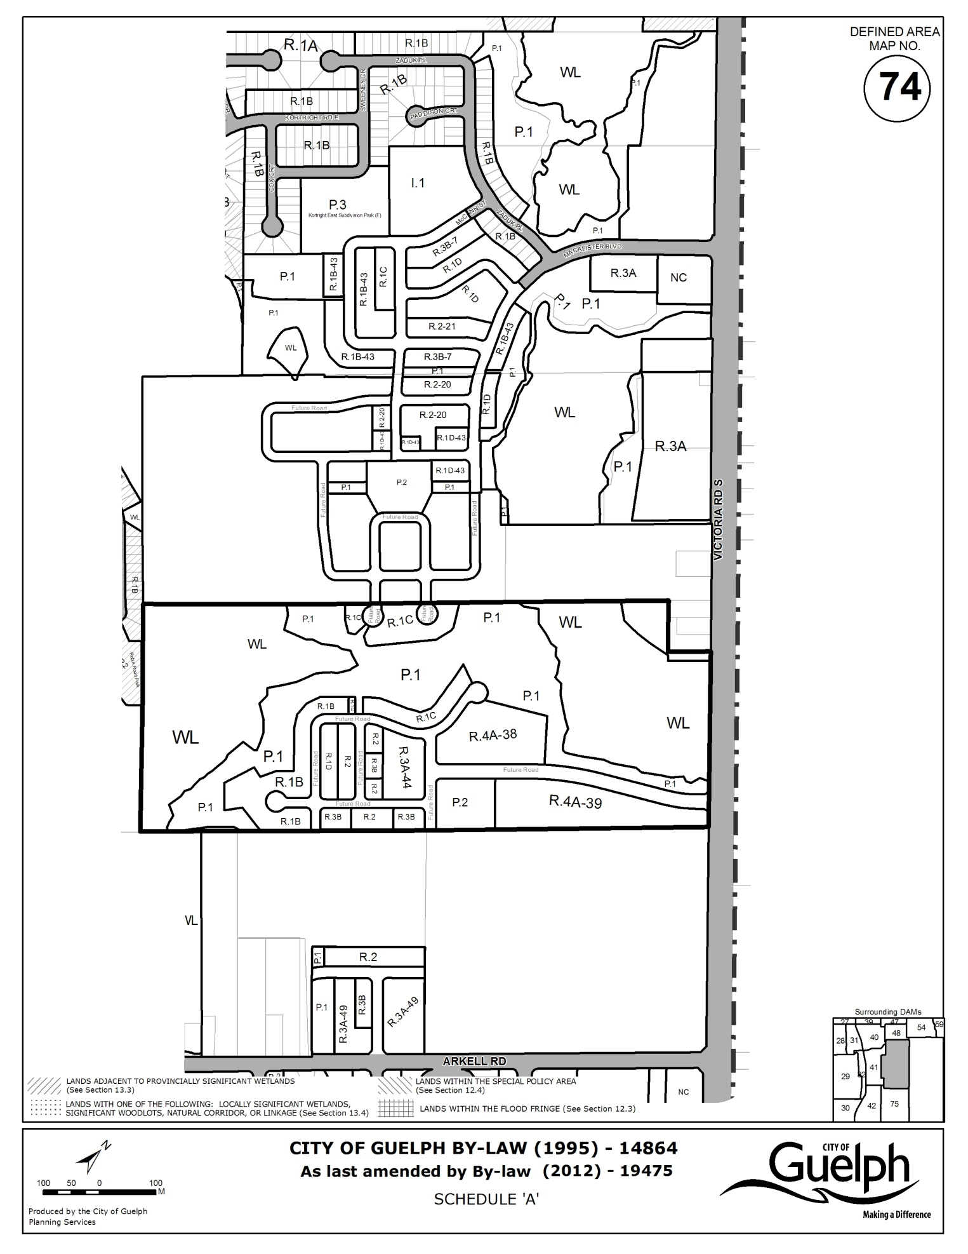

EXPLANATION OF PURPOSE AND EFFECT AND
KEY MAP FOR BY-LAW NUMBER (2012)-19475

1. By-law Number (2012)-19475 has the following purpose and effect:

This zoning bylaw will implement Phase 3 of the Kortright East Residential Plan of Subdivision (File 23T-01508/ZC1007) approved by City Council on October 1, 2012.

The zoning bylaw applies to lands legally described as Part of Lots 3 and 4, Concession 8, Geographic Township of Puslinch, municipally known as 927 and 1023 Victoria Road South in the City of Guelph. The subject lands have a total site area of 15.897 hectares (39.3 acres) with frontage on MacAlister Boulevard and McCann Street. The lands are bounded to the north by the Phase 2 residential subdivision lands and to the west and south by additional development lands owned by the developer. Existing residential and open space development on Robin Road and Olga Circle is located further to the west. The lands are bounded to the east by Torrance Creek Wetlands and associated open space blocks that were dedicated to the City during the registration of Phase 2.

The existing land use designations on Schedule 1 of the Official Plan applying to the subject property are "General Residential" and “Non-Core Greenlands Overlay”. The General Residential designation permits all form of housing. The large-scale Kortright East Residential Plan of Subdivision has been developing in phases over the past several years based on the City’s annual Development Priorities Plan. This bylaw rezones the central part of the development lands, according to City Council’s approval on October 1, 2012.
The subject lands were annexed into the City of Guelph in 1993 and are currently zoned Agricultural (A) and Hazard (H) as described in the Township of Puslinch Zoning By-law 19/85. To implement the approved draft plan of subdivision, the bylaw will rezone the lands to allow the development of 34 on-street townhouses, 62 semi-detached dwellings and 119 single-detached dwellings for a total of 215 residential dwelling units.

Both the standard and specialized zones in the bylaw contain a specific list of permitted uses and also a list of regulations that will guide the development and housing design in each zone. The details of the specialized zoning are contained in the Bylaw which also highlights the specialized regulations for each zone.

The proposed zoning amendment was considered by Guelph City Council at a statutory Public Meeting on December 13, 2010. Council approved the application conditionally on October 1, 2012.

Further information may be obtained by contacting or visiting Planning, Building, Engineering and Environment, 837-5616, extension 2362, City Hall, Guelph, Ontario.

Persons desiring to officially support or object to this zoning amendment must file their support or objection with the City Clerk, City Hall, Guelph, as outlined on the page entitled "Notice of Passing". Any comments or objections which you may have previously submitted are considered to have been unofficial and for the City's guidance only.

- Key map showing the location of the lands to which By-law (2012)-19475 applies:

KEY MAP



