THE CORPORATION OF THE CITY OF GUELPH

By-law Number (2013)-19673

A by-law to amend the Official Plan for the City of Guelph as it affects property known municipally as 35 & 40 Silvercreek Parkway South and legally described as Part of Lots 2 and 3, Concession 1, Division “F” (formerly Guelph Township) and Part of Lots 7, 8, 9, 11, 12, D and E, all of Lot, West side of Guelph & Galt Railway, Part of Napoleon Street (closed by Order instrument No BS 12480)Registered Plan 52, designated as Part 1, 61R10726: and Part Lots 3, 21 and 22, Division “A” (formerly Guelph Township) designated as Part 3, City of Guelph (OP0506)(OMB File #O070094)

WHEREAS the Ontario Municipal Board issued an Order PL070533 on January 12, 2010, to amend the Official Plan pursuant to Section 17 of The Planning Act, R.S.O. 1990, c.P.13:

NOW THEREFORE THAT THE FOLLOWING BE ENACTED:

1. Amendment Number 38.1 to the Official Plan for the City of Guelph, as amended, consisting of :
Part A- The Preamble: the rationale and background information in support of the amendment;
Part B –the Amendment: the specific text and mapping changes introduced to the Official Plan for the City of Guelph;
and Part C – The Appendices: other background information relevant to the amendment;

as attached hereto as Schedule “1” is hereby adopted by Order PL070533 of the Ontario Municipal Board.

IN FORCE AND EFFECT BY ONTARIO MUNICIPAL BOARD ORDER ON JANUARY 12, 2010; FILE NUMBER O070094

SCHEDULE “1”

PART A - THE PREAMBLE

PURPOSE

The purpose of Official Plan Amendment No. 38.1 is to redesignate the former Lafarge lands on Silvercreek Parkway South from Industrial to a number of different land use designations to allow a contemporary mixed use development. The amendment also includes specific policies for the development of the area to be known as the “Silver Creek Junction”. These include Urban Design objectives and policies, infrastructure requirements and specific policies for the various land use designations which include:
- Mixed Use Node;
- Specialized Corporate Business park; and
- High Density Residential.

Location

The subject property affected by this proposed amendment is a vacant parcel of land located both east and west of Silvercreek Parkway South and bounded to the north by the Canadian National Railway main line, to the south by the Guelph Exeter Railway secondary line, and to the west by the Hanlon Parkway (see location map below).

Basis

Approval of the amendment would be consistent with the Provincial Policy Statement.
The modified application also conforms to the intent of the Growth Plan for the Greater Golden Horseshoe. The proposed amendment would allow a compact, mixed use, pedestrian friendly intensification of a brownfield site within the built boundary of the City of Guelph that meets the guiding principles and policies set out by the Growth Plan for the Greater Golden Horseshoe.
The proposed amendment conforms to the policies of the City’s Official Plan including:
- The modified application conforms to the Commercial Policy structure of the City as set out by Official Plan amendment No. 29 which implemented the results of the Commercial Policy Review for the City of Guelph.
- The application has specifically satisfied the tests for the establishment of a new mixed use node set out by Sections 7.4.49 to 7.4.52 of the Official Plan.
- The proposed Official Plan amendment appropriately satisfies the matters to be considered under Section 9.3 of the Official Plan.
- The modified proposal meets the policies pertaining to the development of mixed use nodes found in Sections 7.4.5 to 7.4.14. of the Official Plan.
- The proposed high density residential component of the proposal conforms to the applicable residential policies in Section 7.2 of the Official Plan.
Approval of the application represents good planning for all of the above reasons, and in addition, would achieve a number of public interest objectives and benefits, including the following:

- redevelopment of a large, centrally-located, derelict brownfield site which has been vacant and unused since it ceased its final productive industrial use in the mid-1990’s;
- provision of a long-planned grade separation at the intersection of Silvercreek Parkway and the CNR;
- a stormwater management solution that would contain upstream flows from the Howitt Creek drainage area, during major storm events;
- protection and rehabilitation of Howitt Creek and its related valleyland system which bisects the site; and,
- implementation of a high standard of urban design, including the creation of a central, public “village market square” as a distinctive focal point for this overall redevelopment precinct.

PART B – THE AMENDMENT

All of this section entitled “Part B – The Amendment” constitutes Amendment No. 38.1 to the Official Plan for the City of Guelph.

Details of the Amendment

The Official Plan for the City of Guelph is amended as follows:
Item (1) Schedule 1 - Land Use Plan of the Guelph Official Plan is hereby amended by changing the “Industrial” land use designation applying to the subject lands, which comprise the former Lafarge lands, to “Mixed Use Node”, “Specialized Business Park”, “High Density Residential” and “Open Space”, which are noted as “Silver Creek Junction” as per the attached Schedule “A”
Item (2) The Official Plan is amended by adding a new Section 7.18 “Silver Creek Junction”.

Section 7.18 “Silver Creek Junction”

These policies apply to the area highlighted and noted as “Silver Creek Junction” on Schedule 1 – Land Use Plan.

In addition to the general Urban Design objectives and policies of subsection 3.6, the following urban form statement, objectives and policies apply to the Silver Creek Junction lands.

7.18.1 Urban Form Statement – Silver Creek Junction

The area contains the former LaFarge lands, an abandoned brownfield site, straddling Silvercreek Parkway between the CNR and Goderich and Exeter (GEXR) rail-lines south of Paisley Road, abutting the Hanlon Expressway. Redevelopment of these lands shall be focused around the creation of a central, urban “village market square” straddling Silvercreek Parkway which will assist in creating a neighbourhood composed of a mix of land uses.

The public village market square feature will be complemented by a cohesive, mixed-use redevelopment scheme permitting a range of land uses, including large-format and specialty retail, a range of employment uses, institutional uses, high density residential uses and open space on the surrounding lands. The central village market square area will house a limited range and scale of specialized service commercial uses, mixed use and live work arrangements that are intended to serve the surrounding employment and residential uses.

The redevelopment scheme on the subject lands shall also incorporate a new neighourhood-scale public park that links the central village market square to the Howitt Creek valley to the east. The development will also involve the re-alignment of a portion of the existing Silvercreek Parkway through the central part of the lands, to the extent appropriate, to optimize a functional and cohesive layout of the mix of uses proposed. A new local public road east of re-aligned Silvercreek Parkway will also be developed to provide frontage and access for the above-noted neighbourhood park and a series of viable redevelopment blocks for employment and high density residential uses in the area between Howitt Creek and Silvercreek Parkway.

7.18.2 Urban Form Objectives – Silver Creek Junction

- To provide a desirable mix of compatible land uses that include a variety of building types to minimize travel requirements between homes and places of employment or shopping.
- To ensure an innovative development, which reflects the City’s commitment to environmental sustainability, compact development and energy conservation.
- To enhance the function and naturalization of Howitt Creek and provide pedestrian views and access to this feature.
- To provide active and passive recreational opportunities to help fulfill the City’s recreational and open space requirements.
- To create a variety of public spaces (streets, squares, and parks and open spaces) that encourage social interaction and provide pedestrian connections throughout the development.
- To require high quality built form oriented to all streets, including Silvercreek Parkway, throughout the development.

7.18.3 Urban Design Policies – Silver Creek Junction

- Public streets will be developed to provide a high quality urban environment with reduced setbacks, street trees and other landscape features and on-street parking.
- Parking areas, loading and other less desirable design elements will be screened from public streets by buildings or landscaping.
- Outdoor storage of goods or materials shall be prohibited with the exception of seasonal products.
- The development will include extensive landscaping and plantings associated with the development shall generally be native trees and ground cover.
- Public safety and security will be considered in the development including the optimum visibility of public open spaces, adequate lighting, multiple pedestrian routes and opportunities to control the speed of vehicles.
- Reduced parking standards shall be considered for all land use components within the development to encourage alternative transportation alternatives.

7.18.4 Infrastructure Requirements – Silver Creek Junction

Redevelopment of the former Lafarge lands is dependent upon certain key improvements to public infrastructure, most notably:

- the construction of a grade-separated crossing of the CN main line by an improved Silvercreek Parkway;
- the extension of Silvercreek Parkway northward to connect with Paisley Road; and;
- the construction of a new stormwater management facility on open space lands east of Howitt Creek, to accommodate existing off-site (upstream) storm flows during major storm events.

The site-specific implementing zoning provisions shall include the use of holding “H” provisions to address required infrastructure improvements, including the Silvercreek Parkway/CNR underpass, other required road projects and traffic improvements, the remedial stormwater management facility, related land dedications (i.e. for roads, stormwater management, parks and open space) and the pre-requisite site plan approval and registration of the related agreement on title to the subject lands, prior to the redevelopment of the lands.

7.18.5 Land Use – Silver Creek Junction
The Silver Creek Junction lands are designated “Mixed Use Node”, “Specialized Corporate Business Park”, “High Density Residential” and “Open Space” on Schedule “A” and shall be subject to the following site-specific policies for the applicable designations:
7.18.5.1 Mixed Use Node:
The Mixed Use Node is intended provide a wide range of retail, service entertainment and recreational commercial uses as well as complementary uses including open space, institutional, cultural and educational uses, hotels, and live work studios. Medium and high density multiple residential development and apartments shall also be permitted in accordance with the policies of Section 7.2.

The policies contained in Sections 7.4.4 to 7.4.11 shall apply to the Mixed Use Node.

The Silver Creek Junction Mixed Use Node is divided into 2 Sub Areas as follows:

Sub Area 1:
A maximum of 22,760 sq m (245,000 sq. ft.) of retail gross leasable floor space shall be permitted in Sub Area 1 only as shown on Schedule “A”. This total floor area will be composed of:

- a maximum of one (1) large-format retail store comprised of either a warehouse membership club or a home improvement retail warehouse, to a maximum gross floor area of 13,470 sq. m (145,000 sq. ft.),
- ancillary retail stores (excluding supermarkets), to a maximum aggregate gross floor area of 9,300 sq. m (100,000 sq. ft.), in a minimum of at least two (2) separate buildings, to be located in Sub-Area 1 only as shown on Schedule “A” to this amendment, subject to a maximum retail unit size of 3,716 sq. m (40,000 sq. ft.).
Commercial development in this area shall incorporate a reduced retail parking standard, to be established through the site-specific implementing zoning provisions.

Appropriate phasing requirements shall be imposed on the retail commercial components in Sub Area 1 through appropriate implementing zoning provisions.

Sub Area 2:
The maximum of 3,900 sq. m (42,000 sq. ft.) of service commercial gross leasable floor shall be permitted in Sub Area 2 only as shown on Schedule “A”. This area shall be subject to a restricted range of service commercial uses, to be established in the implementing zoning by-law; the policy intention is to focus on true convenience-oriented service uses to serve the neighbourhood such as restaurants, financial institutions and personal services. The range of permitted uses will also allow a mixed use design with residential or office space permitted above ground floor commercial and live-work arrangements. A minimum building massing equivalent to two (2) storeys (7.6m) shall be achieved in the buildings adjacent to the central “village market square.” Buildings shall be located close to the street line with primary entrances facing the street and grouped in manner to reinforce the limits and identity of the village market square focal point. Reduced building setbacks shall also be encouraged from the public streets, to help define the streetscape and enhance the pedestrian environment.

Commercial development in this area shall incorporate a reduced parking standard, to be established through the site-specific implementing zoning provisions.

7.18.5.2 Specialized Corporate Business Park

Within the “Specialized Business Park” designation on the east side of Silvercreek Parkway adjacent to Howitt Creek, development shall conform with Section 7.9 of this plan and the following:

- permitted uses shall include a range of employment activities including offices, research and development facilities, computer establishments and laboratories that are compatible with the adjacent residential uses. Complementary uses such as institutional (schools and religious establishments), a public or private recreational facility or club, as well as high density residential uses shall also be permitted provided that they are limited in scale and do not detract from the primary development of the lands for employment purposes; and,
- reduced building setbacks and minimum building heights shall also be required, to help define the streetscape and enhance the pedestrian environment.

7.18.5.3 High Density Residential

Within the “High Density Residential” designation on the east side of Silvercreek Parkway adjacent to Howitt Creek, development shall conform with the Sections 7.2.41 to 7.2.46 of this plan and with the following:
- residential development may take the form of individual apartment buildings on separate parcels, or a single cohesive scheme comprising several buildings and may include Nursing or Retirement homes;
- development shall generally occur in buildings ranging in height from 3 to 8 storeys, provided that the height and massing of buildings shall be sensitive to the proximity of these lands to existing low density residential development to the southeast, on the opposite side of the Goderich and Exeter (GEXR) rail line adjacent to the south edge of the site; Further floor space indices (FSI) may be used to control the design of the developments; and,
- notwithstanding the density provisions of Policy 7.2.43, the minimum net density of residential development of the subject lands shall be 175 units per hectare; the intention of this site-specific policy is to require a minimum of 350 residential units to be developed on these lands.

Item (3) Section 7.4.12 of the Official Plan setting out retail floor space allocations for the designated Mixed Use Nodes shall be amended to add the westerly portion of the subject site, as a fifth designated Mixed Use Node, as follows:

- Silver Creek Junction: 22,760 sq. m. (245,000 square metres) subject to the specific restrictions set out in Section 7.18.5.1.

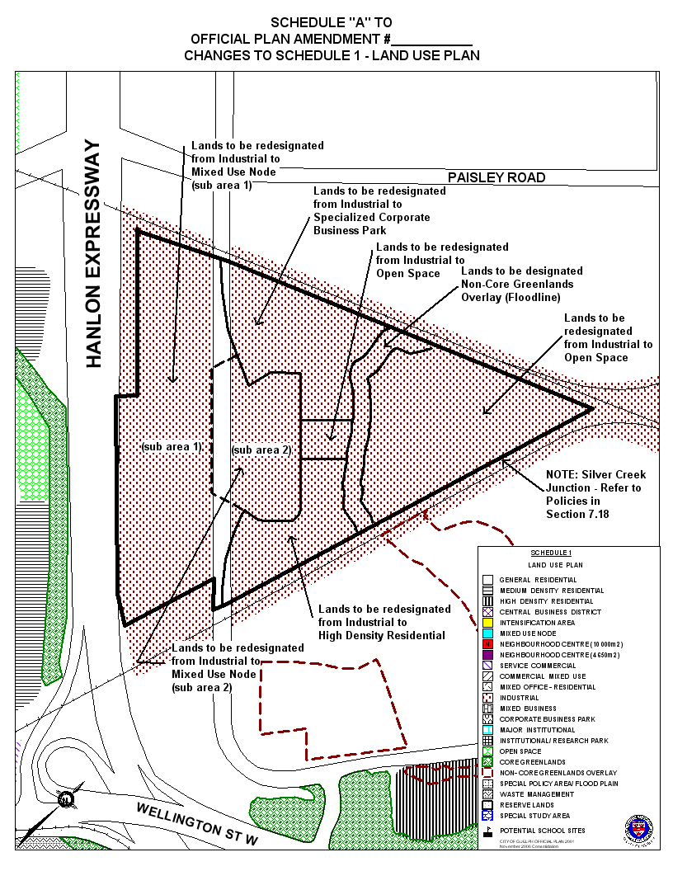
PART C - THE APPENDICES

38.1

The following appendices do not form part of Amendment No. 38.1, but are included as information supporting the amendment.

